Ramon Veal

EGR 125

10/24/18

Project 2

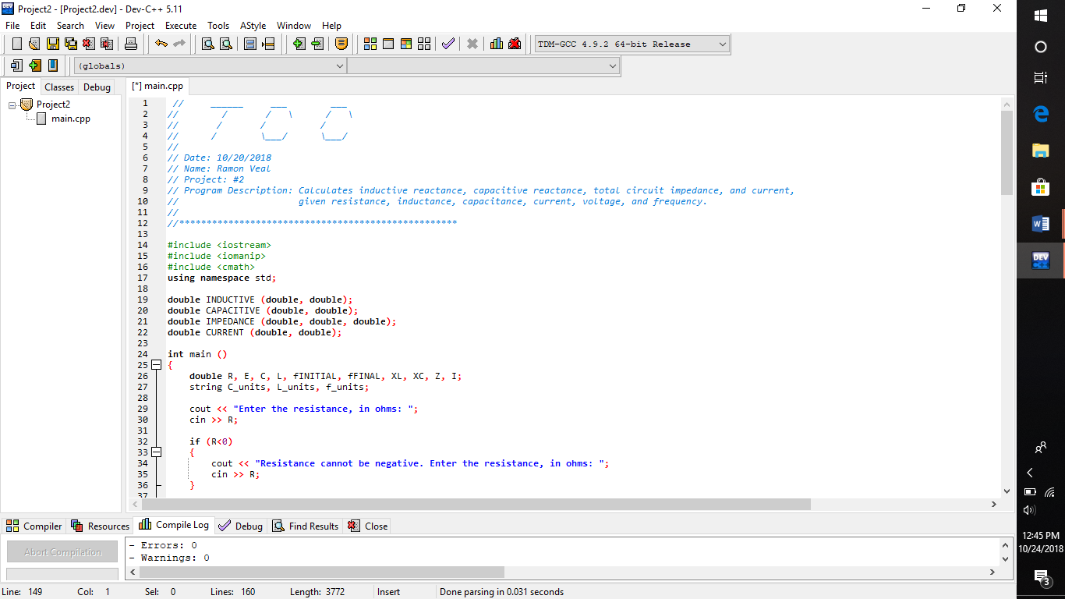

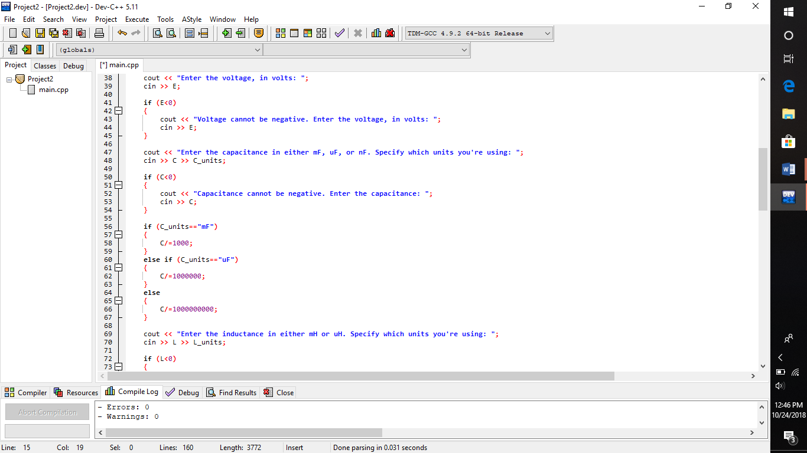

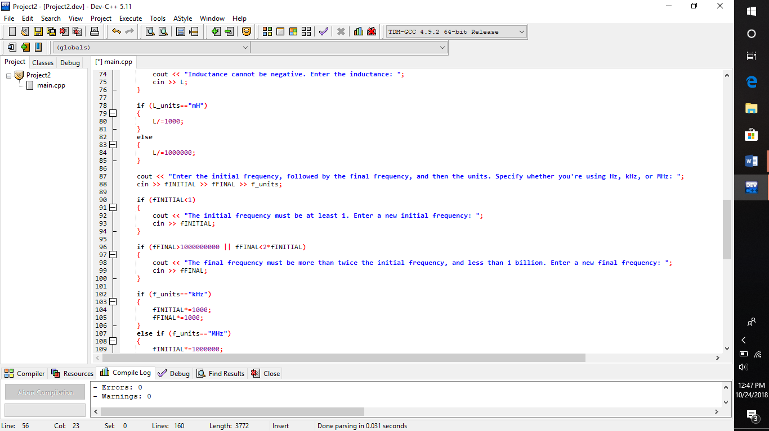

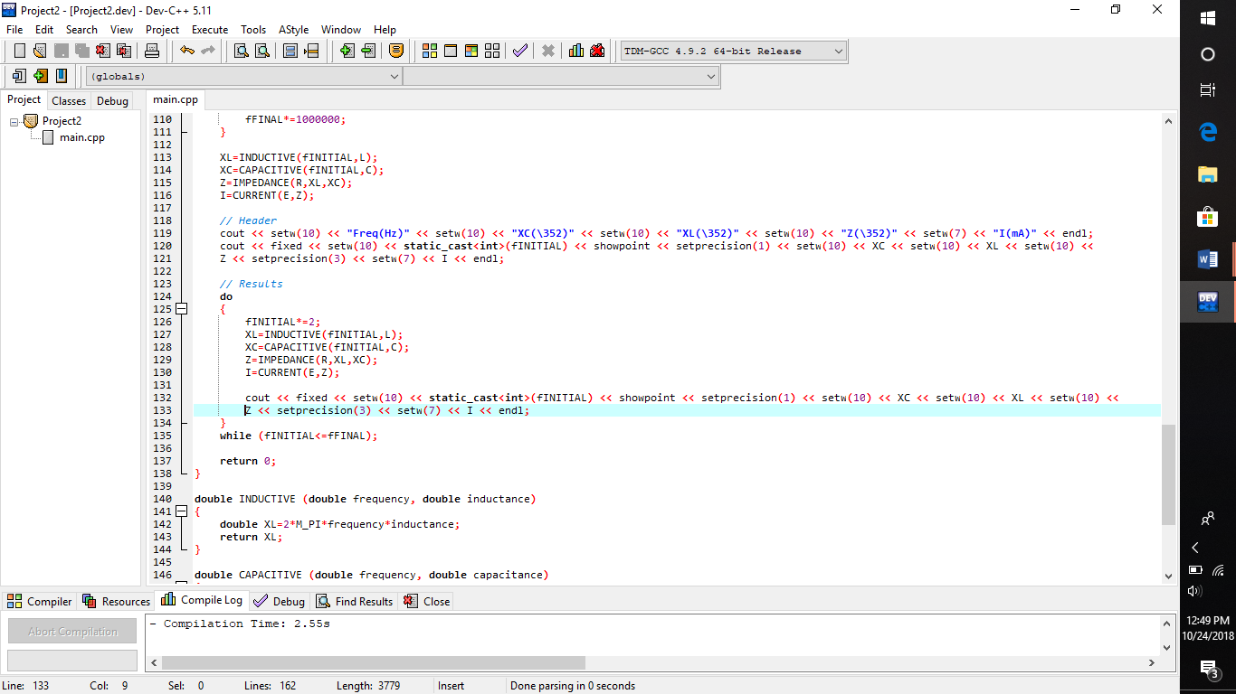

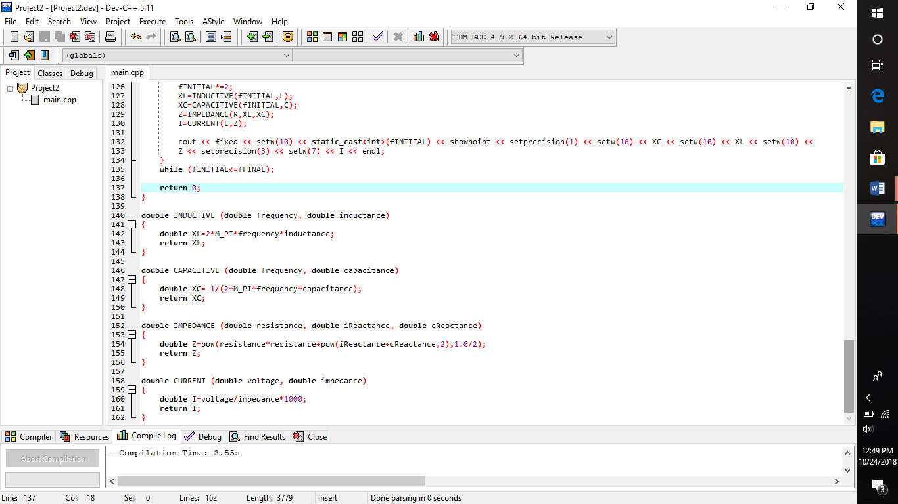

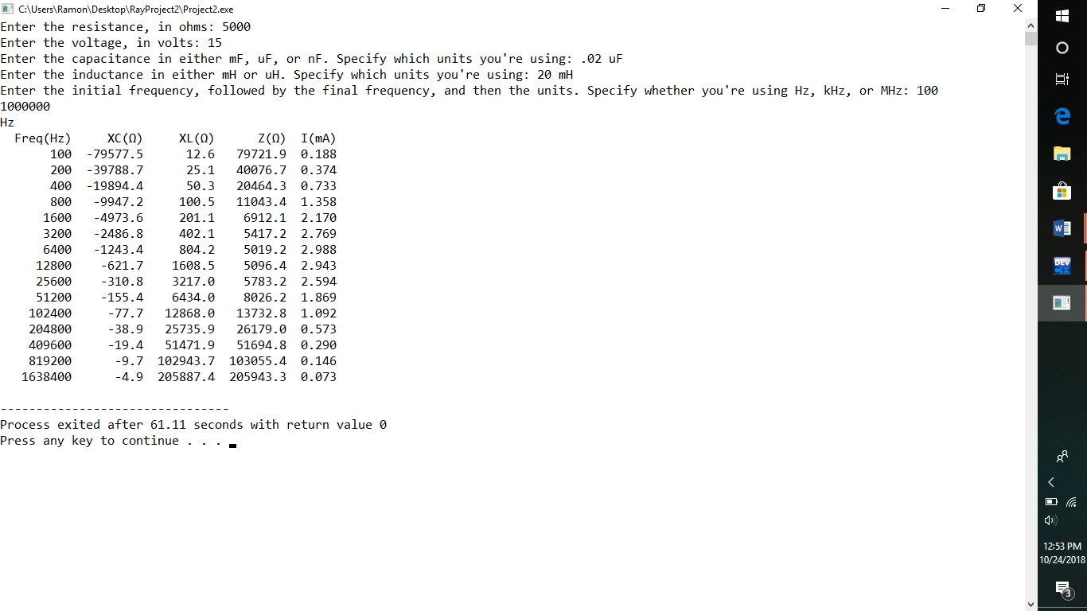

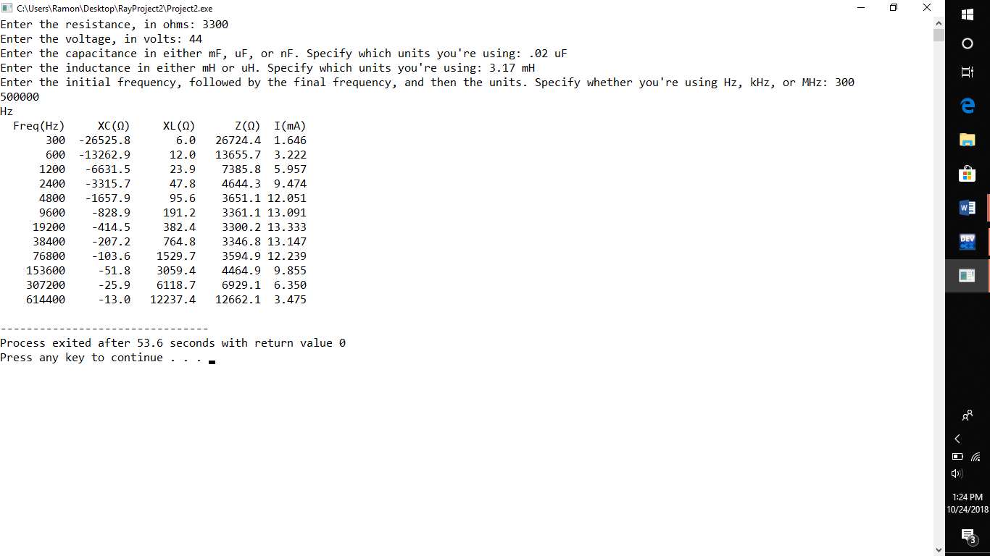

**Discussion**

*Performance*: Calculates inductive reactance, capacitive reactance, total circuit impedance, and current, given resistance, inductance, capacitance, current, voltage, and frequency.

*Extra credit features*: None

*Potential improvements*: Excel graphs. Allow units to be next to each value, which vary to accommodate for sig figs. Custom library.